Admin Boundaries TWG 10/11/2022 Meeting Notes

Attendees:
- Pam Bond, ITS (ran meeting)
- Wilma Robertson, ITS
- Sarah Lawrence, Clearwater County
- Marc Camin, ISP
- Monica Carash, Bonner County
- Jeff Cook, IDPR
- Todd Quast, Cassia County
- Abigail Stahl, Bonner County
- Megan Burns, Montana State Library (mburns2@mt.gov)
- Bill Reynolds, Nez Perce County
- Cole Rosner, IDWR
- Heather Studley, Bannock County

Counties:
County boundaries from the Census are currently not the best. Counties need to work with the Census to make this best available. Wait on moving the County Boundaries Framework Dataset nomination through the process.
Wilma: Different counties have different levels of work to digitize their county boundaries. For example, Cassia and Payette County. Asked Bill what kind of work they have done in his region. Bill – grabbed the Esri layer, found the legal descriptions in the State statue, and edge matched and cleaned up. Doesn’t mean the county tax people adopted it – it is a general mapping layer that the PSAPs have agreed upon. This is an example of special agreements between neighboring counties.
Comment from Bill R: Here are the County boundaries - https://legislature.idaho.gov/statutesrules/idstat/Title31/T31CH1/
Wilma: suggested looking at control points and state statue descriptions and then determine if we have matches with county boundaries (Pam will investigate).
Heather: County boundaries statue is delightfully vague. Not surveyed to the best of her knowledge. Something that has been talked about but hasn’t been done yet. I asked about boundaries along rivers, Bill R – centerline of river on date of survey. WILMA SAID a contractor (Tom) could work with her.
Monica: Not aware that their boundary has been reviewed.
Wilma asked Megan about lessons learned in Montana. Thinking about mountain ridges as boundaries, what about mapping along the watershed boundary (USGS 3DEP). Also helps the census update their boundaries. Has been doing a lot of work going and getting survey points, updating cadastre and NSDI. Have both county lines and county polygons. River boundaries – 1972 set the river centerlines that county boundaries should follow and have just followed those, not re-surveyed. The Montana constitution states that county boundaries follow rivers as they existing when Montana became a State. Not sure if Idaho also has rules like that. Montana maintains both county boundary lines as well as polygons. The lines include a ‘metadata’ field that describes how the boundary is derived (for example: ‘watershed boundary’, ‘PLSS surveyed boundary’, etc). Wilma: How was it working with the census? Use BAS? Megan: Sent them the complete statewide dataset and have also done updates through the BAS program.
Comment from Todd: We have to be careful state boundaries are controlled by the U.S. congress, and the county boundaries by the state. We can create boundaries for our use but that does not change the actual boundary.

ZIP Codes:
State ITS can help facilitate conversations between counties. Heather: the regional post masters are more than happy to help clarify boundaries. Communication boundaries – ZIP code areas are not really areas, they are a rough boundaries around linear networks of roads (ex. How far up this road does this zip code cover). Best guesses, based off postmaster information.
Comment from Bill R: Contact Address Management Services - they will help coordinate - We sat them in a room and hashed out the linear routes to a boundary.
Comment from Abigail: There is a service from USPS that spits out the linear network for a given zip. https://gis.usps.com/arcgis/rest/services/
Abigail: Haven’t made any effective changes because they don’t know exactly the impact of changing those boundaries. Doesn’t want to be changing a bunch of addresses (probably a concern for other counties as well).
Bill: started working on because of their rural addressing project. Started with Address Mgmt Services (affiliated with the USPS and maintain all the addresses. Create map books of addresses for mail carrier routes), will help coordinate. Had to talk to the rural route carriers and do some negotiations. Sent maps back with the post masters and they worked and negotiated with the rural route carriers (they get paid by the # of people they deliver mail to). Even have ZIP codes for no man’s lands (don’t have any mail delivered to). Post office in Lewiston – we deliver the Snake River route, OR WA and ID. All those addresses for mailing are addresses to Lewiston, even though they physically live in another state. Ended up changing 1000s of addresses. Should trickle down to everything, it is important to be consistent and having the same address for mail, physical mailbox on property, NG9-1-1, elections, etc. Remember that it is always about Public Safety when talking to people about these things.
Pam looked up the Address Management System Office for several ZIP code areas across Idaho and they were all:
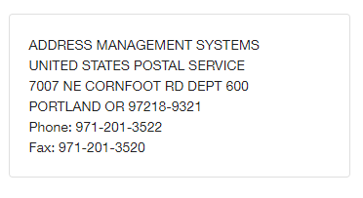
Megan (MT): have not worked on ZIP Codes, this isn’t her area of work. They are working on addressing for elections, and using ZIP codes from …
Heather: While working on Bannock County ZIP code areas, she would reach out to post masters in each ZIP code area. She also asked about mapping at 5-digit or 9-digit ZIP codes. Bill said it gets messy at the 9-digit level. Not much benefit.
UTAH:
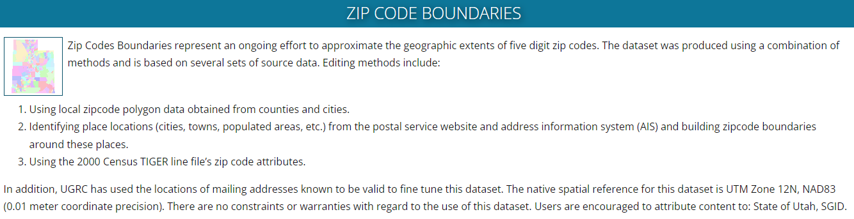

Good information about ZIP Codes: https://www.unitedstateszipcodes.org/

Found this interesting document from WA, County Boundary Update Guidance: https://ocio.wa.gov/sites/default/files/public/Geospatial/CountyBoundaryUpdateGuidelines%20final1.pdf?yq56au
ACTION ITEMS:
County-related:
- Look at the Multi-State Control Points and state statue descriptions, see if we have matches with county boundaries.
  - Pam investigated – although there are some control points along county boundaries, I wouldn’t say there are enough to be really helpful.
- Bring in USGS 3DEP watershed boundaries and compare to linework on ridges used as county boundaries.
  - Pam investigated – I think this is worth discussing more as a group. I could see this data being really useful. Suggest talking with the group about adopting these data as a way to match boundaries at watershed divides.
- Think about creating county lines (like Montana does) - the lines include a ‘metadata’ field that describes how the boundary is derived (for example: ‘watershed boundary’, ‘PLSS surveyed boundary’, etc) Discuss with group.
  - Wilma’s Feedback: I think this is a good idea. For example, if we get an updated watershed boundary layer in the future, then it will be easy to identify which lines need to be updated. Same with river boundaries – I am envisioning the metadata field for the boundaries around Nez Perce to read “Agreement between Counties” or something similar.
- Pam sent an email to Stewart Ward and the Idaho Society of Professional Land Surveyors asking about County boundaries along water – does the boundary remain the same as when first mapped (Statute was created) or should it change as the river/creek centerline changes?
- Stewart’s Response: I do not know of any case law in Idaho that addresses this issue. I have asked other surveyors in Idaho, and we all think that the county boundary would move using the same principles of riparian boundaries as private land. Specifically, if the river moved due to a single major event (flooding) that the boundary would remain as it was. If the river moves due to erosion/accretion, the boundary will move with it. I will ask some of my attorney contacts and see if they know of any case law in Idaho addressing this issue and let you know.
- No response from ISPL as of 10/31/2022.

ZIP Code related:
- Investigate https://gis.usps.com/arcgis/rest/services/ in ArcGIS Pro
  - Pam investigated - In some cases there is some minor parity with county ZIP code data I’ve received, in other cases it is wildly different. If counties have worked with local post masters to create their ZIP code areas, would definitely consider those authoritative. I could see using this data as only a starting point for discussions if the county doesn’t currently have a ZIP code areas layer.
- Reach out to TWG meeting participants for data or volunteers to work on truing up data
- Look to see if NENA has a ZIP code standard.
  - Pam investigated - All I could find:
