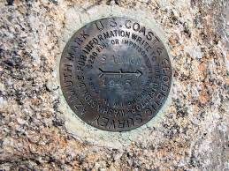
Cadastral TWG

7/26/2022 Meeting Agenda
- Call to order/Roll
- Topics
- Methods for Data Update and Entry to Parcel Fabric by various agencies
- Challenges – Chris
- Potential Methods for data incorporation
  - Data collaboration

- County PLSS Standards – Jan

- Other Agency Standard for Review
- Chris – IDL

- CAD SDI Schema - Byron

- Next Meeting
  - September 27 @ 3 mst

- Action Items

